|  |
| --- |
| Case Study & Variables Application Analysis: |
| Al Bahr Towers |
| Xiang Yuheng Karina 3035947972 |

|  |
| --- |
|  |

1. **Introduction**

The Al Bahr Towers are a unique pair of skyscrapers that currently serve as the new headquarters of the Abu Dhabi Investment Council in the United Arab Emirates. They were designed by Abulmajid Karanouh from Aedas, comprising of two highly identical, 145m tall buildings (Xuereb, 2014). The skyscrapers shown in Figure 1, whose construction incorporates Islamic geometric patterning, are the newest addition to Abu Dhabi’s evolving skyline. The most striking feature of the towers is its innovative dynamic façade consisting of over 1,000 ‘Mashrabiya’ panels that respond to the sun’s movements. Over the course of the day, these panels automatically open and close depending on the sun’s rays, which allow improvements in energy consumption within the building by optimizing natural daylight and controlling temperature gains. The mechanisms of the façade are very similar to the easing and furling of sails on a ship, thus inspiring the name of ‘Al Bahr’, which means ‘the sea’ in the Holy Quran (Karanouh & Kerber, 2015).

This report aims to provide an overview of the towers and conduct a variable analysis on the Mashrabiya panels. Section 2 will provide a brief explanation of the physical properties of the Al Bahr towers, including its location, exterior and interior features, and design aims. Section 3 will focus on the architectural features of the towers, notably the ‘Mashrabiya’ device. Section 4 will describe the process of modelling the façade given different folding methods and calculate corresponding indoor lighting comfort levels. Section 5 offers improvements for analysis and Section 6 concludes the report.

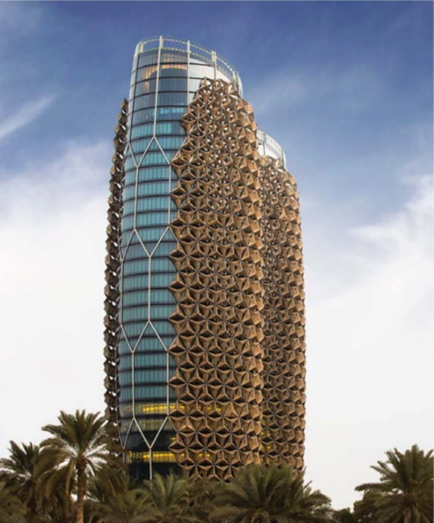

Figure 1: The Ab Bahr Towers

1. **Physical Properties**

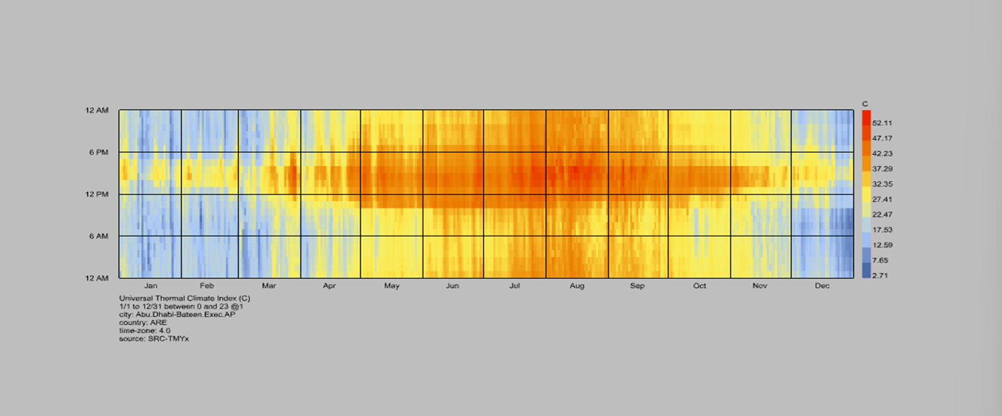The Al Bahr towers are located in the southeastern region of Abu Dhabi, where the region is characterized by outrageous solar radiation levels, temperatures peaking at 49 degrees Celsius (Figure 2), and humidity getting as high as 100% during the year (Karanouh & Kerber, 2015). Based on the thermal climate index, it can be observed that the regional climate is hottest between the summer months (July to September) from 6 pm to midnight. This thus necessitates the need for panels in the façade to regulate the temperature and humidity of the air currents, thus ensuring thermal comfort indoors, in addition to other purposes such as energy saving and maximizing natural daylight.

Figure 2: Universal Thermal Climate Index in Abu Dhabi throughout the year

The shape of the towers resembles a cocoon, meaning that they are elliptical. At the center of the towers is a column 20m in diameter to not only provide stability, but also allow for elevators for both cargo and people (Xuereb, 2014). The bounds of the building employ steel columns that follow a honeycomb structure (Figure 3) in order to accommodate the hexagonal structure of the ‘Mashrabiya’ panels, which will be explained in detail in Section 3.

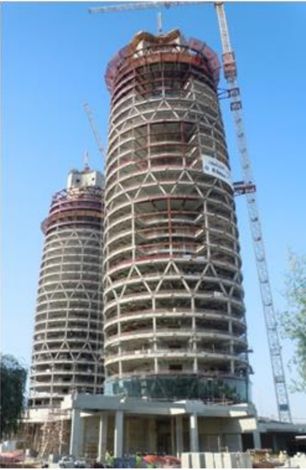

Figure 3: Construction of the Ab Bahr Towers, featuring honeycomb structure

While the towers mainly offer spaces for office use, they also have other spaces containing a 200-seat theater hall, prayer rooms, restaurants, plant rooms, and gymnasium (Xuereb, 2014). There is also a basement for car parking and vaults for banking purposes. Between the towers is an entrance podium, which not only allows entrance to either one of the two towers, but also includes solar panels that heat up the water supply in the buildings. The towers also highlight a multistorey sky garden (Figure 4) that separates the office space from the surrounding landscape at the height of the towers (Xuereb, 2014). Finally, at the top of each tower is an observation level with arched roofs, allowing visitors to admire the city’s breathtaking skyline.

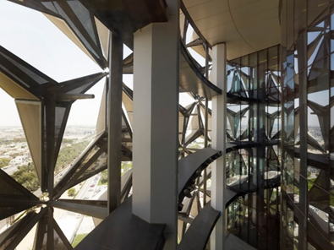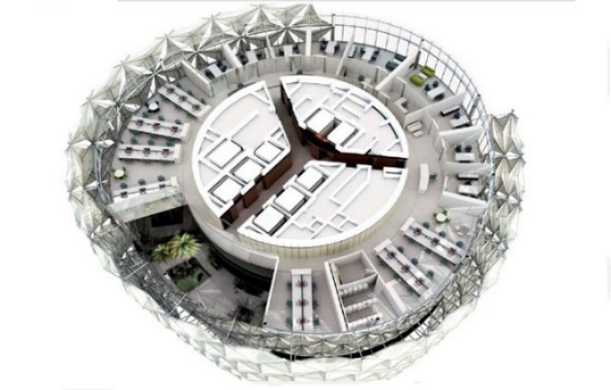

Figure 5: Sky garden view from the interior

Figure 4: Top view of sky garden floor layout

1. **Architectural features**

The defining architectural element of the Al Bahr towers are the ‘Mashrabiya’ devices. The term ‘Mashrabiya’ refers to a traditional characteristic of architecture in the Islamic world, which often involve wooden lattice screens consisting of repeating geometric patterns such as hexagons or circles (Attia, 2018). These screens typically function as ‘dilutors’ of light by deflecting solar rays, whilst ensuring adequate ventilation and shade within the building. Moreover, the geometric layout allows people inside to see the outside, but people outside cannot see the insides, thus providing a sense of privacy. Additionally, the umbrella-like characteristics of a cactus that shield its fragile skin, amongst other protection systems found in nature, served as another source of inspiration for the architects of the Al Bahr towers (Karanouh & Kerber, 2015).

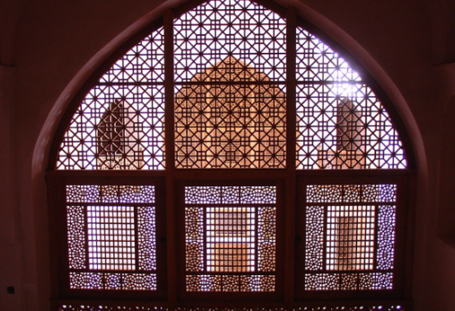

Figure 6: Circular patterns in a Mashrabiya screen

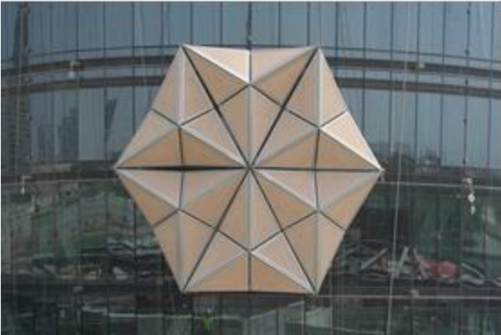1049 Mashrabiya panels were located on each tower of the Al Bahr towers (Attia, 2018). These panels, comprising of triangular units, were clustered together, and were computer-controlled in order to adapt to solar radiation levels. The panels were connected to sun tracking software which controlled how the panels opened and closed according to where the sun was located in the sky (Xuereb, 2014). In addition, the panels were linked to an anemometer to close the panels if the wind speed exceeded the maximum functioning threshold. After 30,000 trials of opening and closing the panels given different temperature, humidity, or wind level conditions, the Mashrabiya devices operate on a pre-programmed software (Xuereb, 2014), which resulted in the building’s exterior to be different according to daily or seasonal changes.

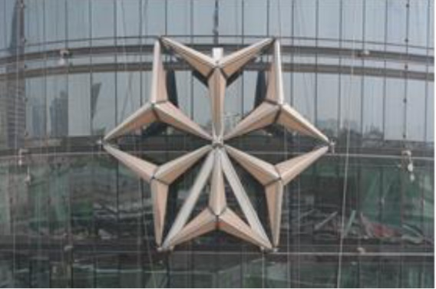

Figure 8: Mashrabiya panels fully closed

Figure 7: Mashrabiya panels fully open

Figure 9 illustrates a detailed 3D model of an individual device.

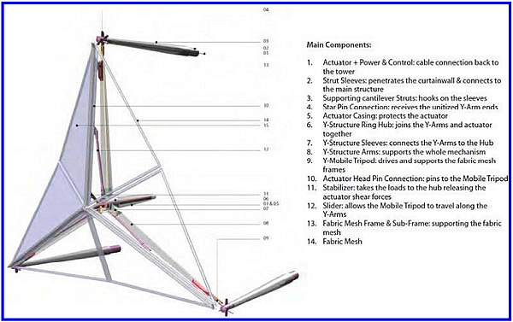

Figure 9: 3D Model of one Mashrabiya unit

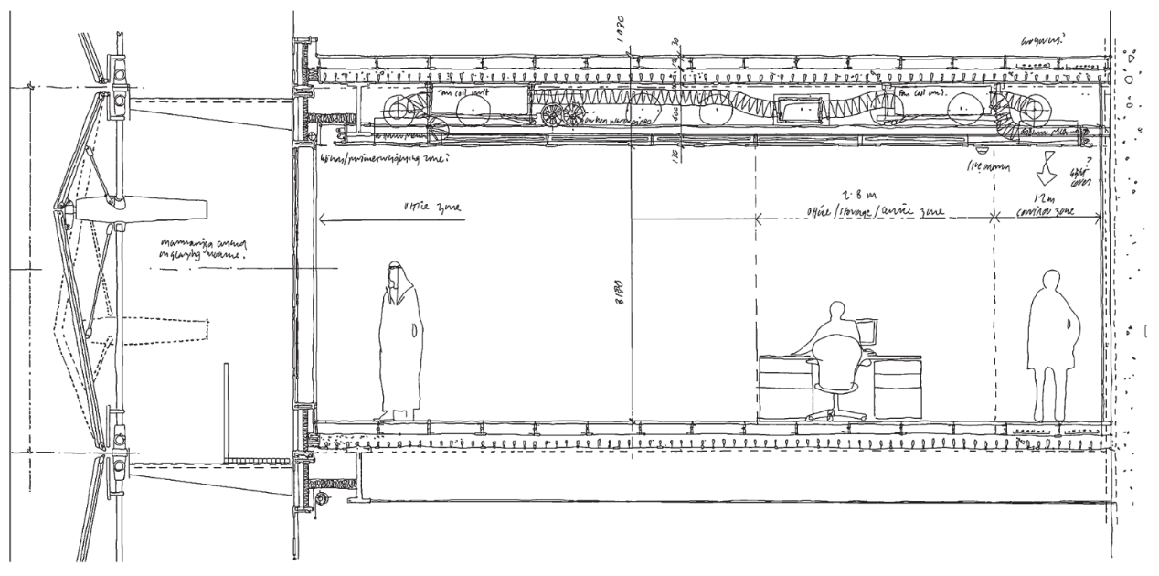When a façade zone is exposed to sunlight, each Mashrabiya unit within the zone will change accordingly. For example, with more sunlight, the device would unfold and close, whereas with less sunlight, the device would gradually open. The goal was essentially to control the level of daylight within the range of 250 – 2000 lux from 9 in the morning until 5 in the afternoon (working hours).

Figure 10: Side-perspective schematic of the façade and the interior structure

1. **Analyzing the Façade and its Applications**

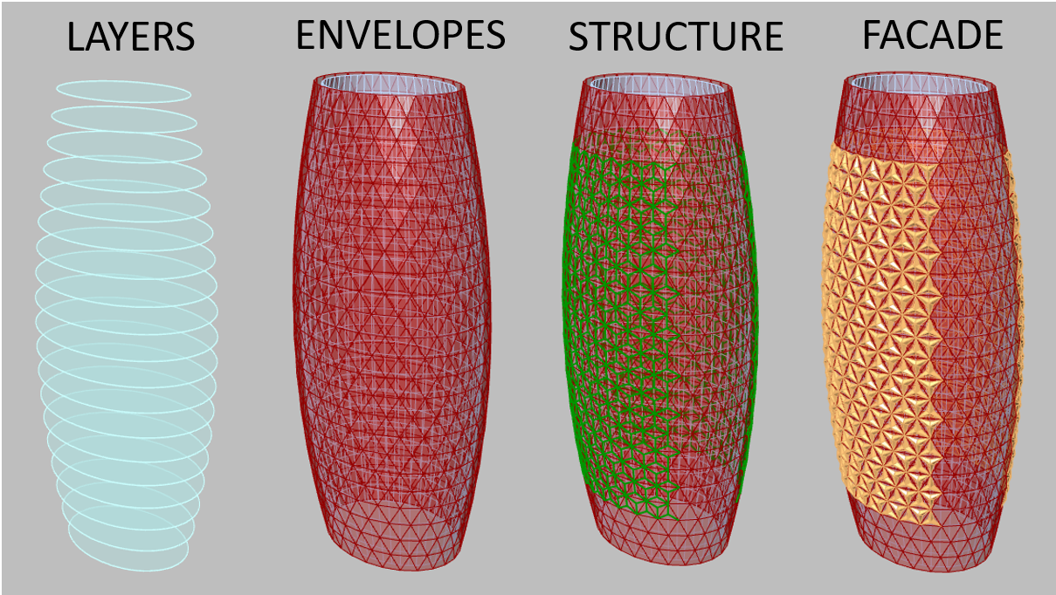To generate the basic structure of the towers, I used Grasshopper to define each layer, one by one. The general things needed to be determined included the number of layers, the circumference and diameter of each layer of the cocoon shape, and the characteristics of each layer, which is thick at the center but thin at the exterior sides. Based on the defined layers, an envelope would be made for both the inner and the outer sections. The outer envelopes were divided into six triangular shapes since each unit of the façade was composed of a hexagonal shape. Following this step, I used Karamba to develop the structure of the façade, which is shown in green in Figure 11. The rendered model of the Al Bahr towers featuring its notable façade is then shown in Figure 12.

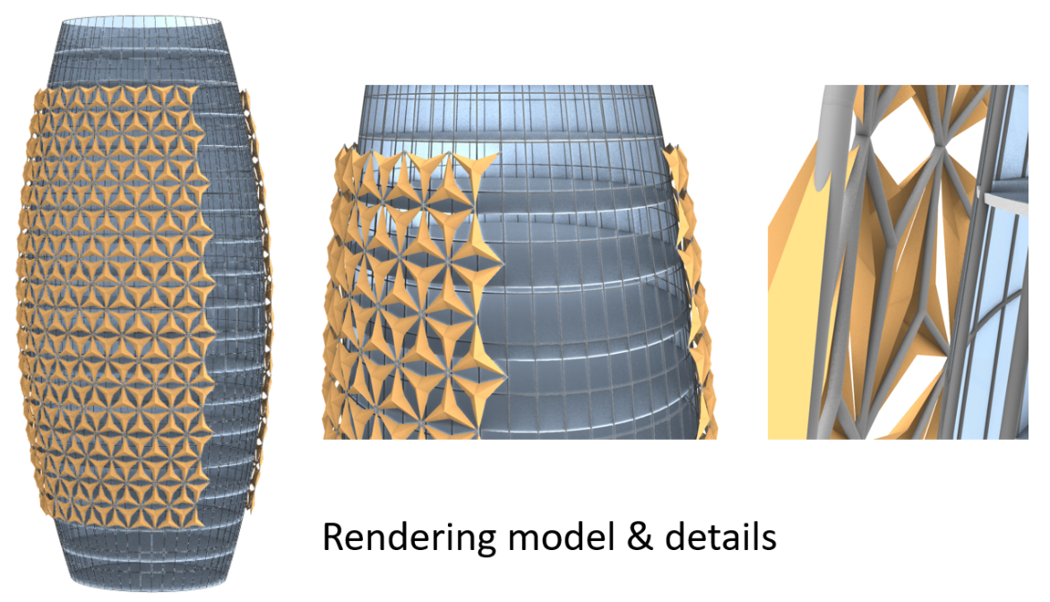

Figure 11: Layers, envelopes, structure, and façade design in Grasshopper

Figure 12: Rendered model of the façade and the Al Bahr Towers

For my design space, my chosen variable was how each unit of the façade changed based on different ways of folding. In the first case shown in Figure 13, I drew solid lines through opposite corners and used them as cutting lines to divide the hexagon into six equilateral triangles. For each triangle, the dotted lines represent the folding lines, which, after folding along the lines, allow the hexagon to have a three-dimensional movement. In the second case shown in Figure 13, I retained the original cutting line to obtain six triangles but drew the folding line through the line of symmetry of the triangle in order to achieve a different configuration. In the third case, I drew the cutting line through the three lines of symmetry of the hexagon, which led to six kite-shapes. I continued to use the cutting lines as the folding lines to obtain the third form of configuration, which resembles a snowflake. In the fourth case, instead of retaining six cutting lines formed by drawing a solid line through opposite corners, I removed one line between two solid lines to obtain three rhombuses. Then, I used the line of symmetry with the longer length as the folding line to create the fourth form of three-dimensional configuration.

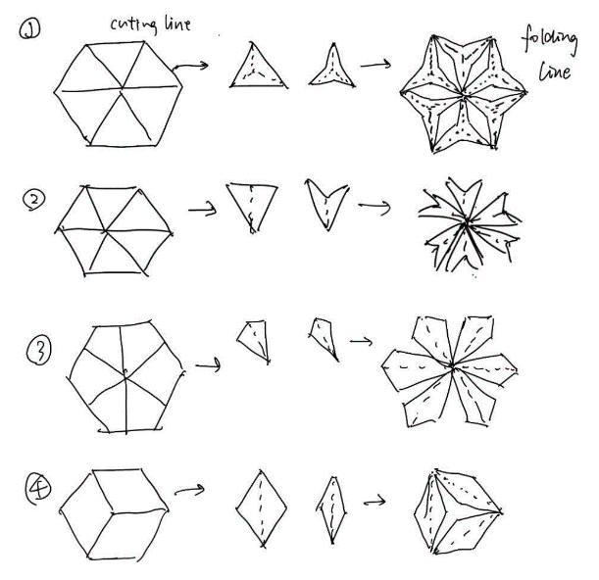

Figure 13: Rough sketch of the changes in the Mashrabiya panels after altering folding style

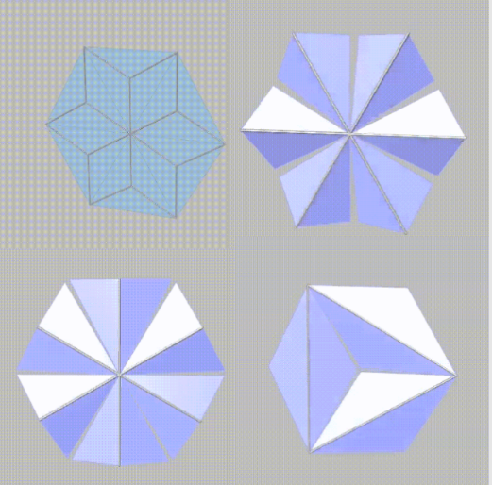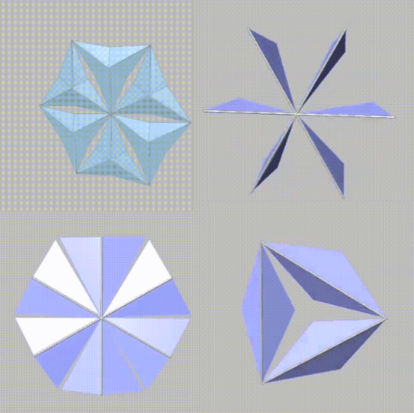

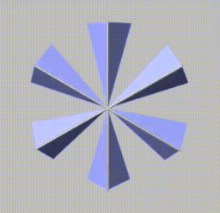

Figure 13: 3D configurations for different cases of folding

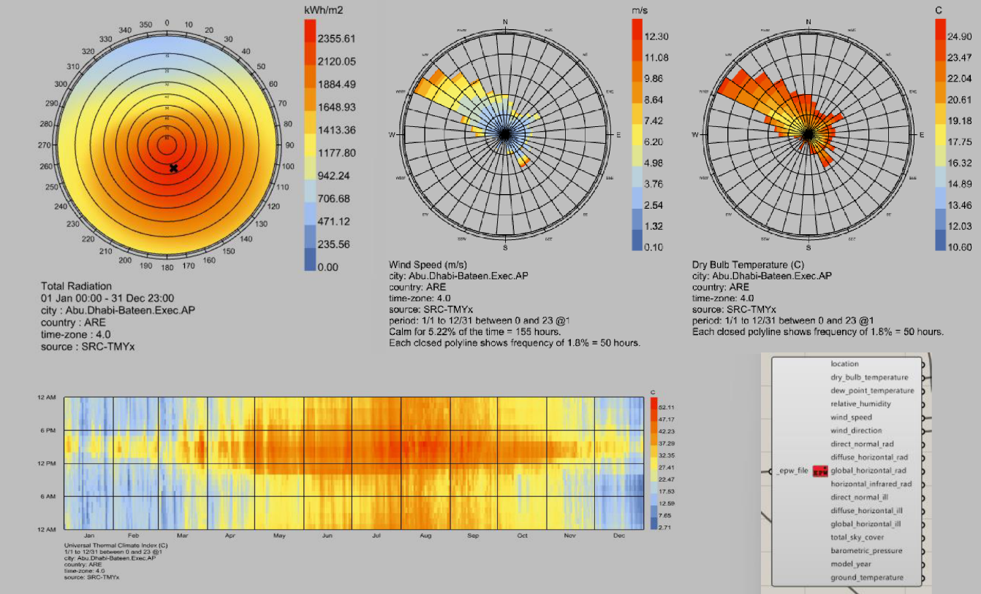Based on Figure 14, we can observe from left to right, the radiation, wind speed, and dry bulb temperature graphs in Abu Dhabi. In the total radiation graph, solar radiation has the highest concentration in the southeast region, whereas in the wind speed graph, wind speeds are maximized near the northwestern region.

Figure 14: Total Radiation, Wind Speed, and Dry Bulb Temperature Graphs in Abu Dhabi

Given the temperature data, I wanted to analyze the comfort level of people within the building based on the degree of indoor lighting. In my model, I used the average solar radiation of sunlight in the afternoon, and based on further research (Karanouh & Kerber, 2015), I assumed of needing no more than 300 lux (a unit for the level of illumination) for indoor lighting comfort. I used the west side of the façade in my analysis and used the largest layer in dimension at the center of the tower as my position of reference.

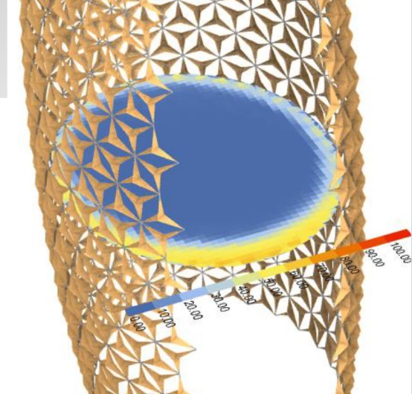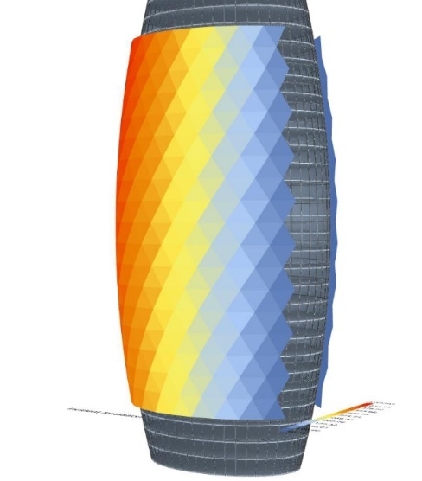

Figure 15: Varied radiation levels on façade (left) and level of exceeding lux on floor plan (right)

Based on the four different configurations of the façade mentioned above, I analyzed the comfort levels of indoor lighting.

In the first case of folding configuration, the upper left corner of Figure 16 shows the three-dimensional transformation of the façade in the afternoon. The red to blue colors on the towers describe the level of sunlight radiation on the towers, with red corresponding to higher levels of radiation and blue corresponding to lower radiation levels. The graph to the right demonstrates how the panels open according to radiation levels in the afternoon to regulate indoor lighting. For example, on the left of the building where radiation is higher, the panels are closed, whereas on the right of the building where radiation is lower, the panels tilt open to let more light in from the less intense direction. The graph at the top right corner illustrates the oval plan of the layer. Given that indoor lighting should not exceed 300 lux to prevent discomfort, after changes to the façade, the oval plan shows areas within this layer that exceed 300 lux, which is highlighted in yellow. The areas shown in blue on this layer are the areas that are confined within the 300-lux limit. Finally, I used Honeybee to calculate the level of comfort based on the proportion of the blue area in the total area of the layer, which demonstrated a level of 73.42% comfort when using the first type of façade configuration.

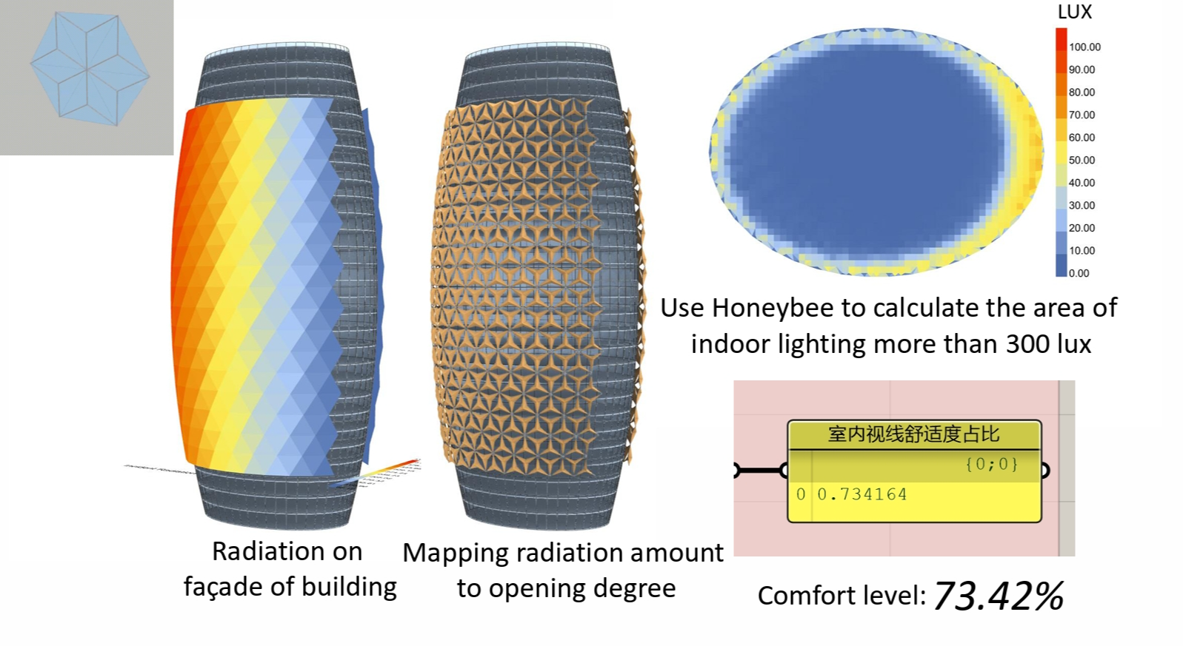

Figure 16: Mapping radiation amounts using 1st folding configuration and calculating indoor lighting comfort level

Similarly, for the second, third, and fourth case of folding configuration, I used Honeybee to calculate the level of comfort, which is shown correspondingly in Figures 17, 18, and 19. We can see that the second case had the highest comfort level of 73.47% amongst all four cases, followed by the fourth case having 72.06% comfort level, and finally the third case with 71.09% comfort level.

Figure 17: Mapping radiation amounts using 2nd folding configuration and calculating indoor lighting comfort level

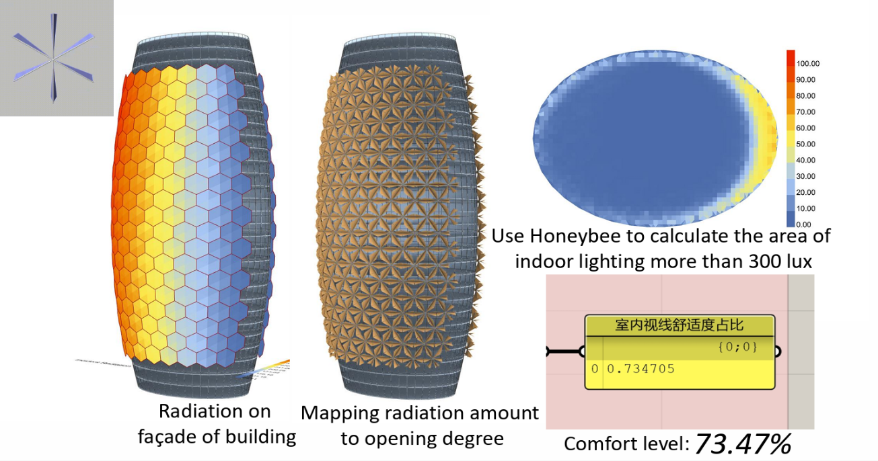

Figure 17: Mapping radiation amounts using 2nd folding configuration and calculating indoor lighting comfort level

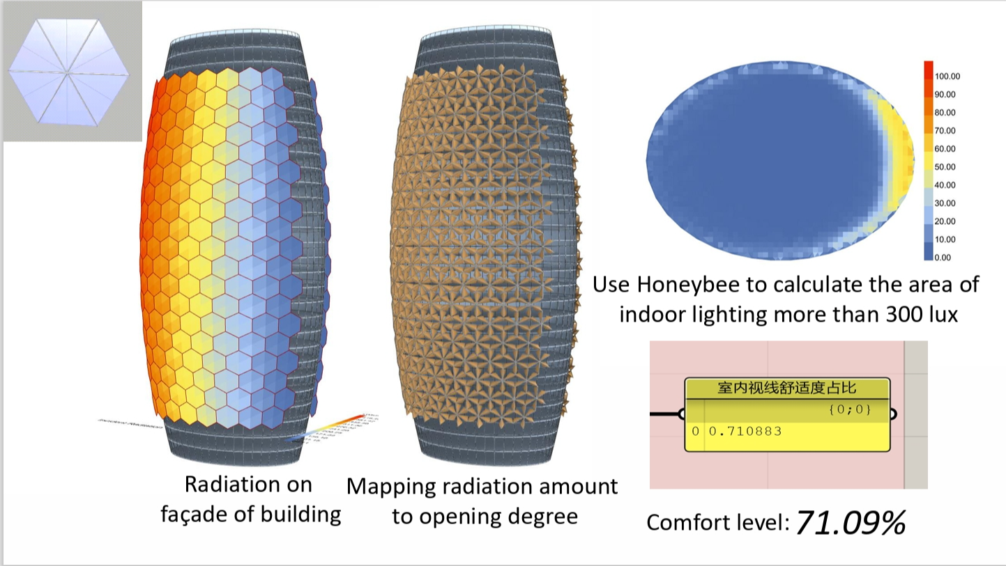

Figure 18: Mapping radiation amounts using 3rd folding configuration and calculating indoor lighting comfort level

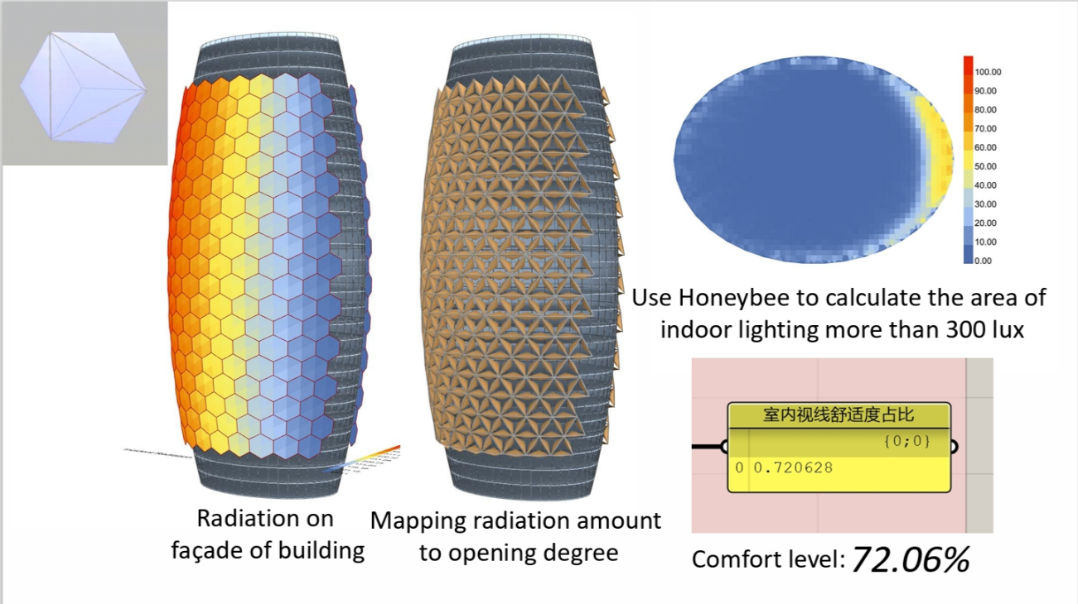

Figure 19: Mapping radiation amounts using 4th folding configuration and calculating indoor lighting comfort level

1. **Model Improvements**

Based on the analysis in Section 4, we observed that the second case of configuration had a higher indoor comfort level than the first case, or the original façade used in the Al Bahr towers. This suggests that we could research different geometrical patterns apart from hexagons and triangles to determine a method of optimizing indoor lighting comfort levels (close to 100%). Moreover, to improve our analysis in the future, we could incorporate the effect of indoor environment and objects on the level of illumination to improve the accuracy of this study.

1. **Conclusion**

The Al Bahr towers illustrate an innovate approach to façade design that adapt to sunlight conditions throughout the day. The Mashrabiya panels open and close through sunlight tracking software to regulate natural daylight within the building, as well as controlling temperature, humidity, and energy consumption. By modelling the façade using varying cutting and folding styles of the hexagon, the second case with triangular folding achieved the highest indoor lighting comfort level. Further studies on other geometric patterns and the interior environmental effects on the efficiency of the façade design could improve the comfort level analysis. Overall, the Al Bahr towers exhibit a clever façade system that harmonizes contemporary skyscraper architecture with the local environment and culture.

**References**

Attia, S. (2018). Evaluation of adaptive facades: The case study of Al Bahr Towers in the UAE. *QScience Connect, 2017*(2). <https://doi.org/10.5339/connect.2017.qgbc.6>

Karanouh, A., & Kerber, E. (2015). Innovations in dynamic architecture. *Journal of Facade Design and Engineering*, *3*(2), 185–221. <https://doi.org/10.3233/fde-150040>

Xuereb, K. (2014). *THE AL BAHR TOWERS – ENHANCING SUSTAINABILITY THROUGH INNOVATION.* Institute For Sustainable Energy, University of Malta. <https://www.um.edu.mt/library/oar/bitstream/123456789/22981/1/2_1_Xuereb.pdf>